**Practice Problem from a previous semester:**

Consider the following scenario and then answer the corresponding questions.

ABC Travel and Tourism specializes in providing tourist packages to customers across the globe and the company has decided to develop an in-house software system that will help customers search for travel destinations based on popularity, budget, visa restrictions, government policies and attractive climatic conditions. Customers will also be able to book their air tickets, hotel and transportation (rental car, public transportation, cab services) through this system. Prior to the booking, the system will allow users to check for their visa eligibility to travel to destinations outside of their country of citizenship. Users will also be able to review and rate destinations or hotels using the system. The company also offers pre-set packages and if a customer decides to go with a specific package, they will be asked to provide the dates for their travel. The system will find an airline reservation, hotel/ transportation choices and create an itinerary for the customer. Customers will not be allowed to customize the pre-set packages.

Once the booking is done, the system should send a notification to the users on the purchase confirmation within 2 hours. Cancellations will incur a 25% penalty, if users are “Gold” members. In all other cases, the reservations will be non-refundable. Customers can pay using their credit cards or Paypal.

Solution 1:

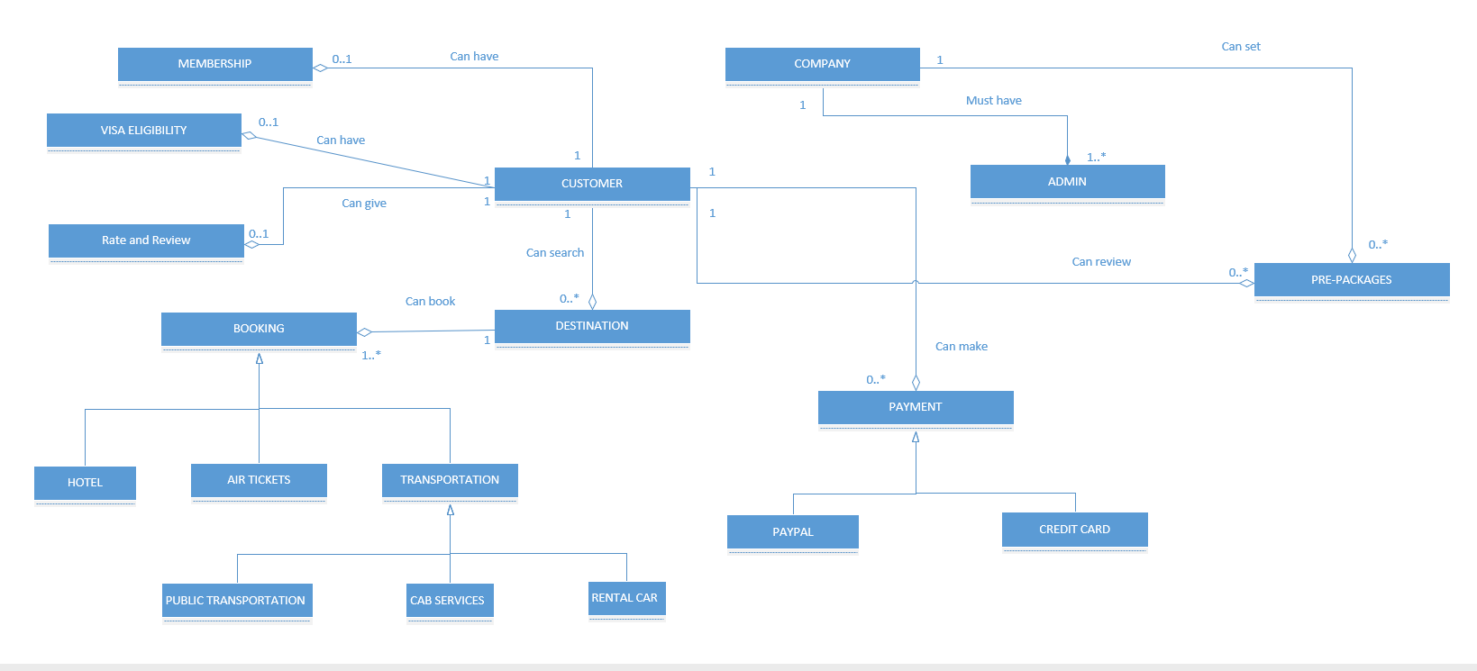

Solution 2:

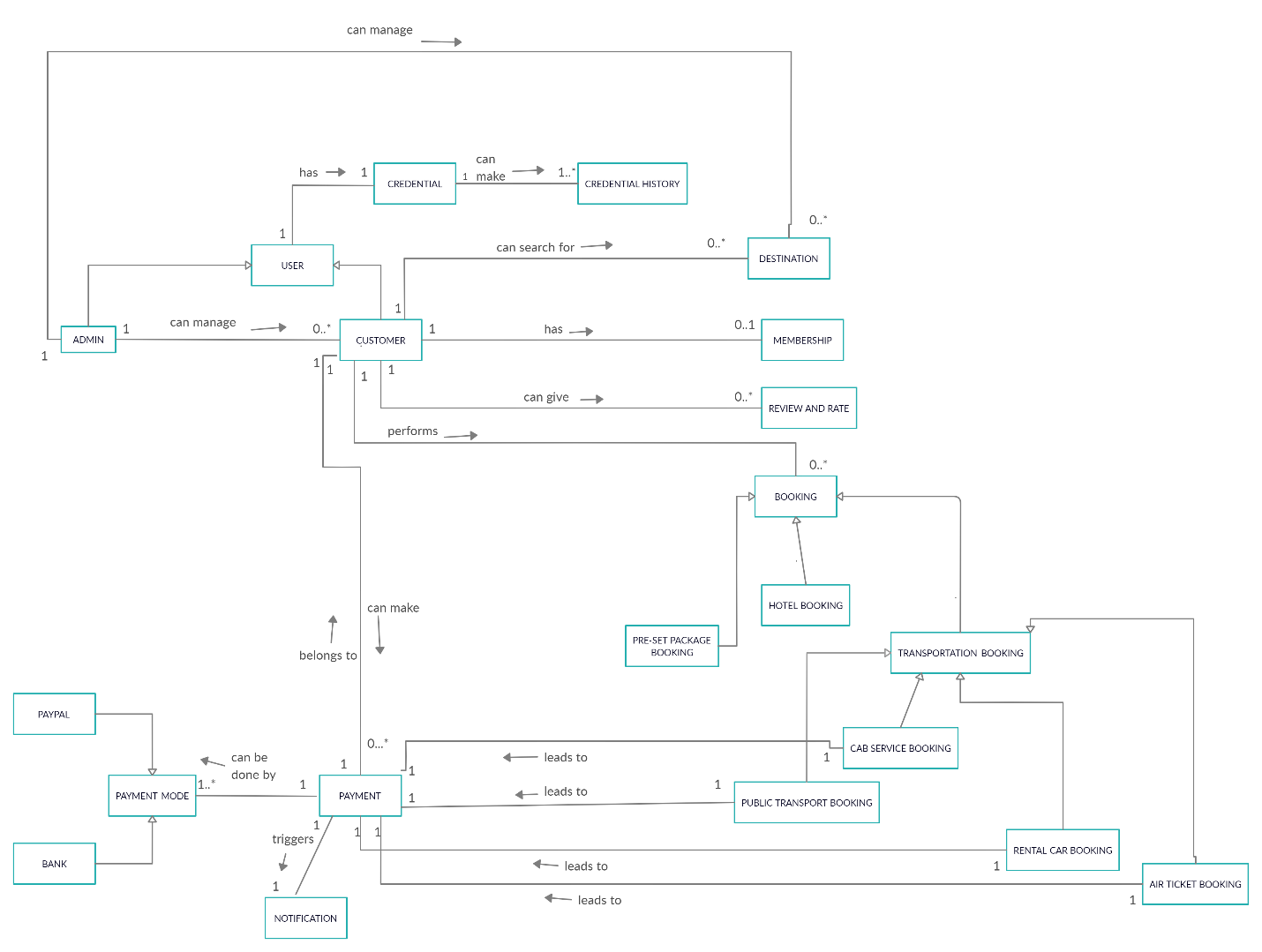

Solution 3:

